OVERALL PROGRAMME EVALUATION REPORT
SBVP ALUMNI MASTERCLASS Online s Module 2 Zambia (4th May 2026 - 8th May 2026)
No. of Respondents: 126
No. of Participants: 126
Response Rate: 100%
--------------------------------------------------

Faculty Reports

Kingsley Kalusha - Long-term sustainability planning
Evaluation Parameter | (%) Individual Score | (%) Programme Average
Punctuality (Commencement and Completion of Sessions) | 96 | 95
How well do you understand the core concepts presented? | 87 | 88
Rate your confidence in applying the new skills learnt | 91 | 85
Degree of Faculty preparedness for the sessions | 91 | 93
Content and methodology of the program | 93 | 95
Quality of class and group discussions | 91 | 91
The information presented in the course is relevant to my work (ministry) | 95 | 95
Average scores | 92 | 92

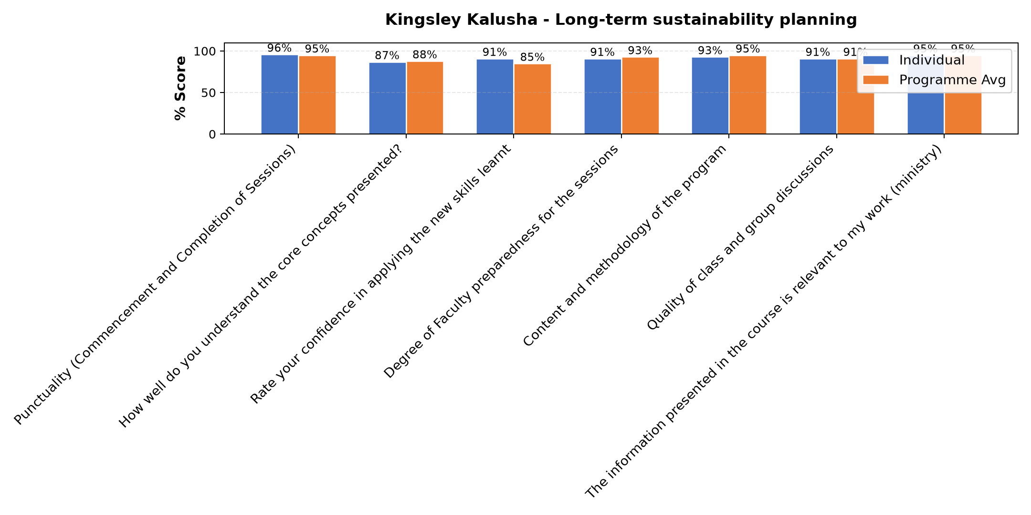

Comments & Feedback
- • Finance to source the demand of the parents because some come from far and transport is difficult for them as a result they prefer to withdraw their children and take them to other near by schools
- • No barriers will prevent me from applying what I have learnt
- • Financial problems
- • We always have Internet network problems
- • Congregation leadership
- • Poor network from participants including myself
- • Trust from leadership of the congregation
- • The part attended was great

Dr. Nancy Nyambura Njiraini - Reflections and Way Forward
Evaluation Parameter | (%) Individual Score | (%) Programme Average
Punctuality (Commencement and Completion of Sessions) | 100 | 95
How well do you understand the core concepts presented? | 92 | 88
Rate your confidence in applying the new skills learnt | 76 | 85
Degree of Faculty preparedness for the sessions | 96 | 93
Content and methodology of the program | 96 | 95
Quality of class and group discussions | 92 | 91
The information presented in the course is relevant to my work (ministry) | 92 | 95
Average scores | 92 | 92

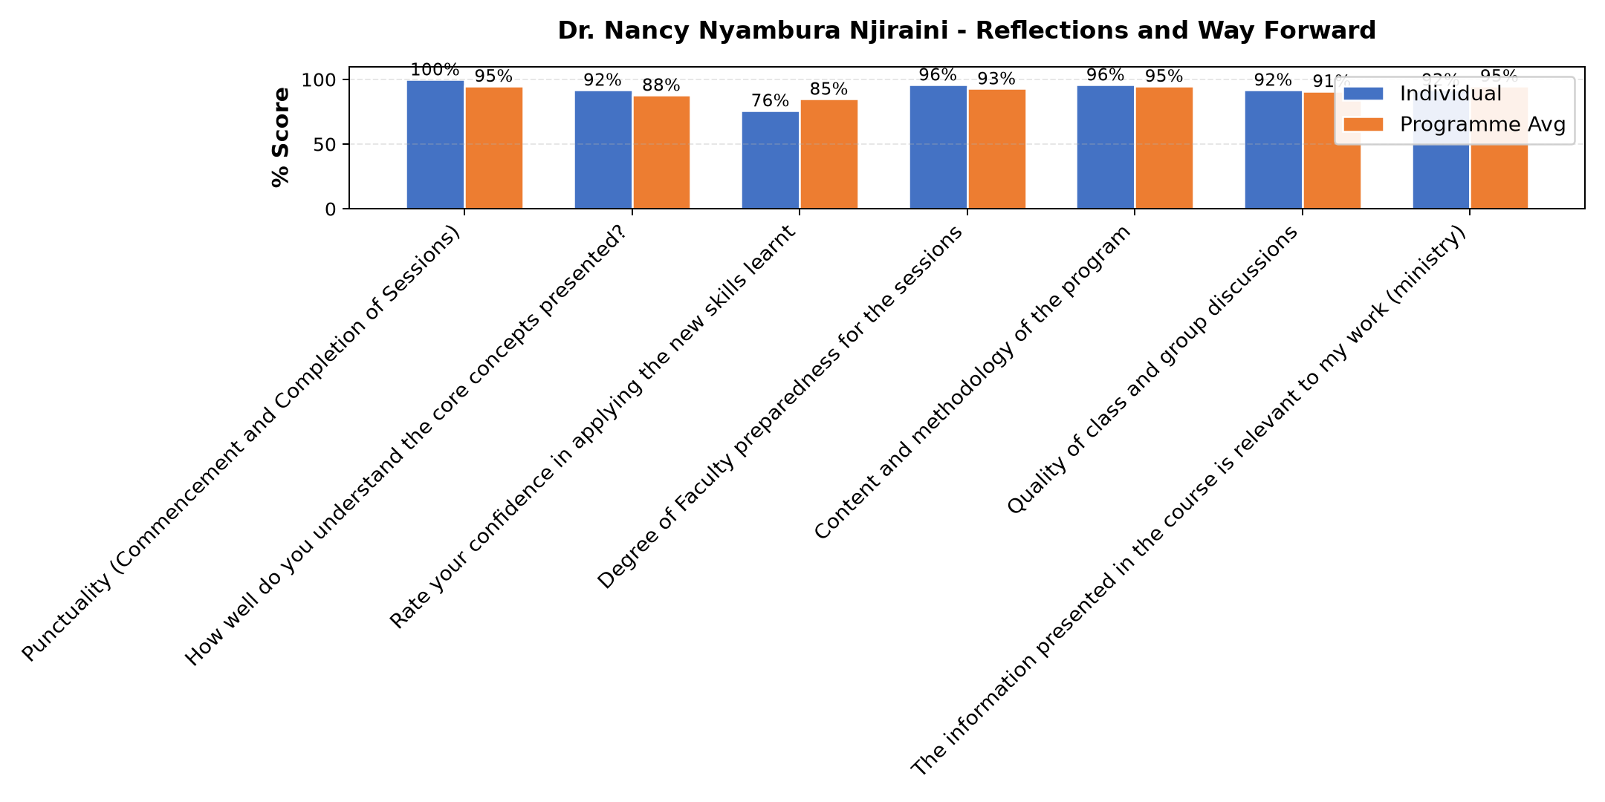

Comments & Feedback
- • Network problem for most participants and absentism
- • Lack of finance
- • The congregation doesn't involve us
- • Effort

Bernard Chege - Review (identify gaps/challenges) your business plan from module 1|| Decide key issues for long-term sustainability|| Identify areas where support is needed|
Evaluation Parameter | (%) Individual Score | (%) Programme Average
Punctuality (Commencement and Completion of Sessions) | 93 | 95
How well do you understand the core concepts presented? | 89 | 88
Rate your confidence in applying the new skills learnt | 86 | 85
Degree of Faculty preparedness for the sessions | 94 | 93
Content and methodology of the program | 94 | 95
Quality of class and group discussions | 91 | 91
The information presented in the course is relevant to my work (ministry) | 97 | 95
Average scores | 92 | 92

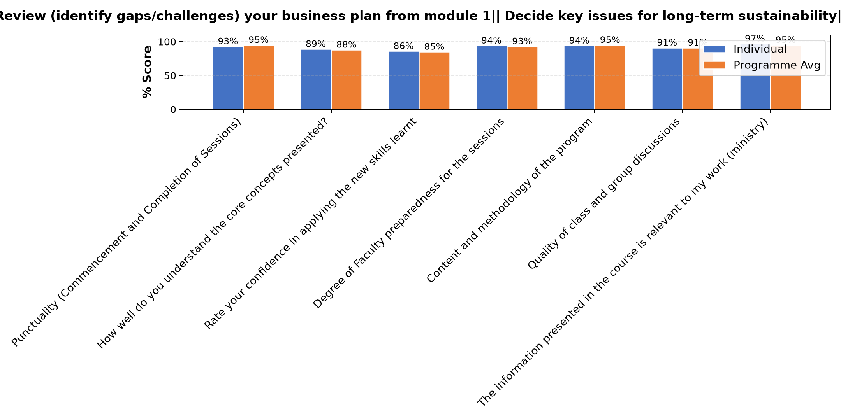

Comments & Feedback
- • Our Main challenge is finances
- • Some team members missed the session, it is draw back.
- • Today the Network system was not favourable
- • capital and funding
- • Finance for building and Transport
- • Financial barier
- • Inadequate Finances and slow response from contractor
- • Internet came a problem for me and malimo can not hear me
- • No barriers
- • I missed some information

Kingsley Kalusha - Social impact measures and planning
Evaluation Parameter | (%) Individual Score | (%) Programme Average
Punctuality (Commencement and Completion of Sessions) | 94 | 95
How well do you understand the core concepts presented? | 83 | 88
Rate your confidence in applying the new skills learnt | 80 | 85
Degree of Faculty preparedness for the sessions | 91 | 93
Content and methodology of the program | 92 | 95
Quality of class and group discussions | 89 | 91
The information presented in the course is relevant to my work (ministry) | 92 | 95
Average scores | 89 | 92

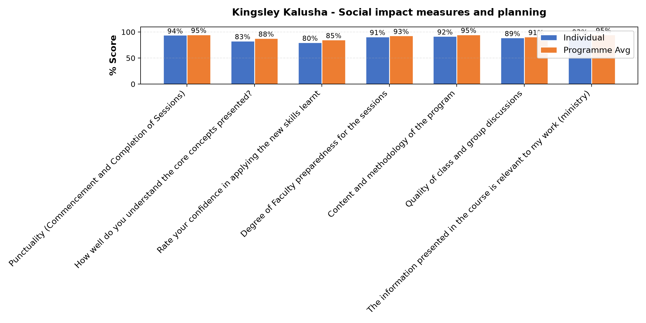

Comments & Feedback
- • I am not directly involed in project
- • No barriers will prevent me from applying what I have leant
- • The Monthly returns paying to some government entities.
- • My effort
- • I need to study it more
- • Network challenges
- • Congregation leadership
- • The time where the session is please. It come without pre preparedness hence missing some sessions because one has to teach.
- • Leadership

Dr. Chilumba Bwalya - enterprise|| Identify Funding Gaps|| Preparing funding plan
Evaluation Parameter | (%) Individual Score | (%) Programme Average
Punctuality (Commencement and Completion of Sessions) | 94 | 95
How well do you understand the core concepts presented? | 91 | 88
Rate your confidence in applying the new skills learnt | 94 | 85
Degree of Faculty preparedness for the sessions | 94 | 93
Content and methodology of the program | 100 | 95
Quality of class and group discussions | 91 | 91
The information presented in the course is relevant to my work (ministry) | 97 | 95
Average scores | 94 | 92

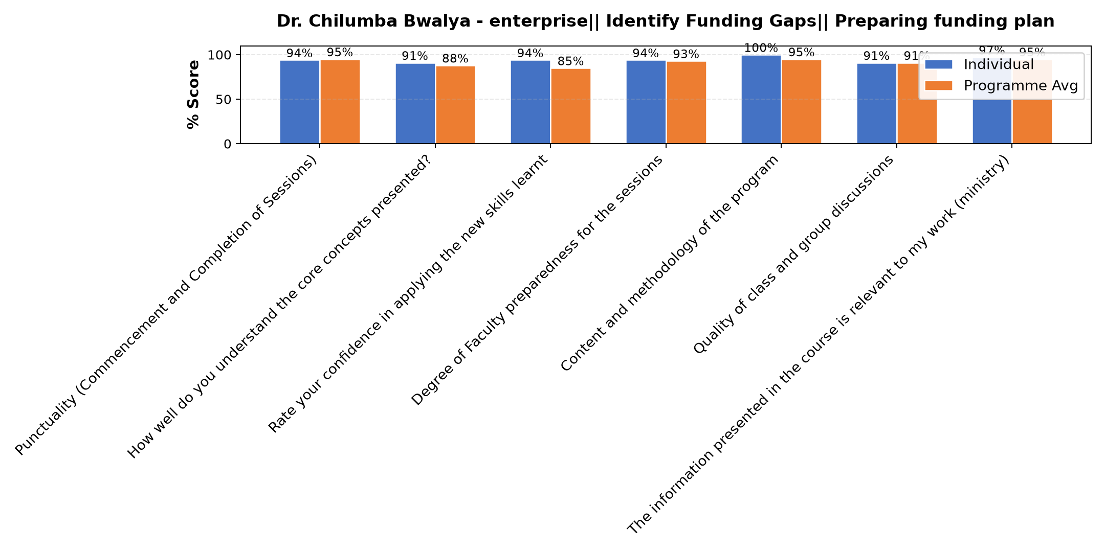

Comments & Feedback
- • No barriers will prevent me from applying what I have learnt
- • Network challenge to most partucioants
- • Today there were few sisters yet the content way very important
- • I had challenges of network
- • Lack of enough finances to achieve the demands of our stakeholder ( parents of our learners)
- • Lack of time. Too busy at the moment

Department Reports

Are there any other comments and/or suggestions that you may want to add?

Comments & Feedback
- • Some sisters missed lessons due to other commitments, leaving gaps in group discussions and continuity. I don't have a suggestion but think of a way to bring on board everyone. Maybe it is the timing/ dates.
- • If you plan to have another session please remind us so that we continue to learn because learning does not finish.
- • Keep in touch with the sisters and continue informing what is on the ground
- • I'm impressed by the fact that the Strathmore University had to make a follow course to see how we are doing as well impact more knowledge is us. I feel strathmore University is really doing alot to empower us as Religious Women. I'm grateful to the Sponsors and all who make this empowerment possible

General Comments

Comments & Feedback
- • Good information to help us
- • This course is very good and helpful for our enterprises. The knowledge gained ia great. I would love to see major Superiors have this topic so that when they are planning for the Congregation, they are strategic in the area of sustainability.
Secondly we need help in Capital and funding.
- • The session was enriching i have learnt a lot especially from Mr.Benard Chege the facilitator of the day, his explanation and examples given have made me understand how to run our social enterprise effectively . I also appreciate all the sisters who were participating actively , they have helped me how to market our products and services effectively. Thank you so much.
- • No comments. The gap is on my side the dates set for classes are always crashing with the dates I have to attend to the Provincial assignments and meetings.
- • We need money to finish the building
- • Thank you for today's session that was very educative
- • Thank you
- • Thank you for the knowledge
- • Beautifully presented
- • The bulk of information was left towards the end
- • Very excellent Mwalimu
- • Thank you very much for the knowledge
- • Where was Dr Chilumba hiding all these years. He presented so well. And thanks Strathmore University for choosing good Lecturers.
- • To continue encouraging the sisters to attend the sessions
- • Thank you for broadening my thinking capacity about Funding and that in our social enterprise we need to think about the continuity and how to move to serve more as well as to partner with business people who have been running their business for so long without giving up and how they venture into different activities .
- • Thank you and God bless
- • The lecture was very good and professional. Looking at our capacity, we needed two days for this so that the work could be broken in two. The Lecture is very good and knows the content well.
- • immense gratitude to our teacher who took us in today's session.
- • The session was excellent reminding me on how we can change our society using theory of change so that even our learners and workers can sustain themselves through different skills we teach them to become better citizens who will put our nation to a developed future.
- • I need to create more time for keeping records to date and measure the impact
- • Thank you very much.
- • It was too technical for me to follow well since I was driving
- • Thank you very much much
- • Thank you
- • No trust from leadership of congregation
- • Lack of trust
- • Thank you so much for the input about the pillars of sustainability it has helped me to know to deal with parents who can not pay school fees on time. We shall start implementing by writing reminders on time rather than sending them back.
- • The presenter was very excellent. The content was clear and life giving
- • It was a good presentation
- • No trust from the congregation leadership.for not giving freedom to work.
- • Thank you very much.
- • Thank you for the insights. Very inspiring
- • Very well presented and good material. We need capacity building on succession plan or a template for this plan.
- • Of not being to the place of interpraise it's so difficult to work
- • Looking forward to more.
- • This was a very good lesson and well presented. Kindly share notes by email.
- • Continue supporting all the congregations using your skills we really appreciate.
- • Have lost interest of implementing but am also doing gardening at tobit girls secondary school where am working from which provides good nutrition because the variety of vegetables
- • The reminder of what we have been learning enhanced the knowledge acquired even more
- • Thank you so much

Overall Evaluation
Evaluation Parameter | (%) Score
Overall program evaluation | 92
Average score | 92

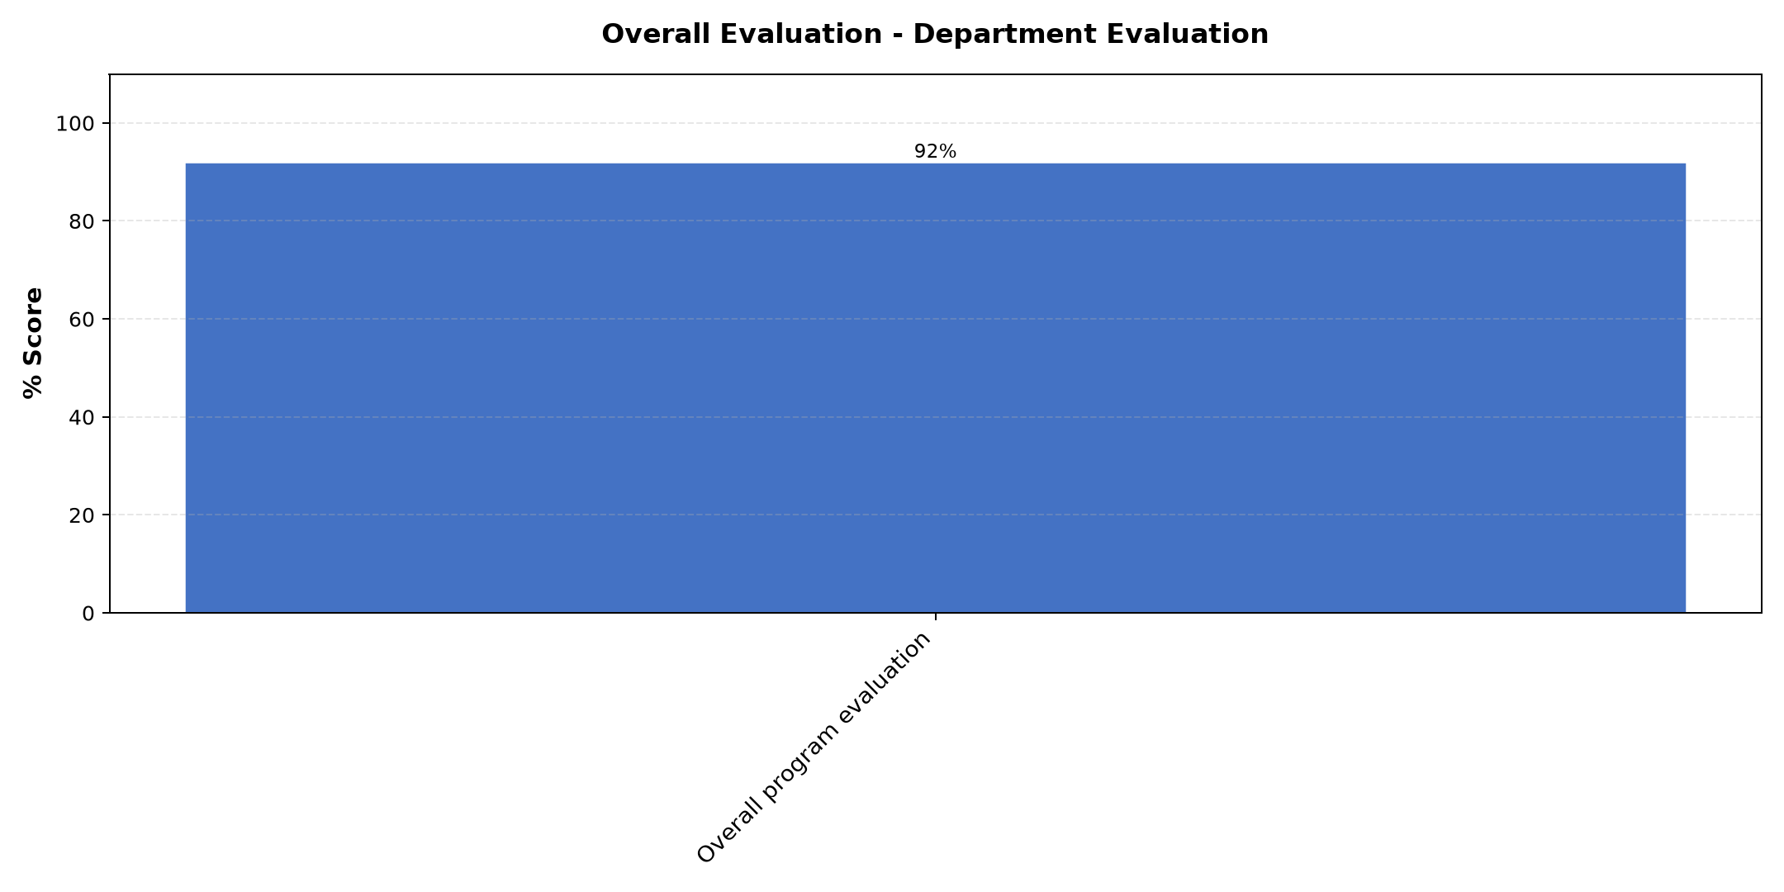

Comments & Feedback
No comments recorded.

Program Manager (Paul Bikundo)
Evaluation Parameter | (%) Score
Punctuality (Commencement and Completion of Sessions) | 100
How well do you understand the core concepts presented? | 100
Rate your confidence in applying the new skills learnt | 100
Degree of Faculty preparedness for the sessions | 88
Content and methodology of the program | 92
Average score | 96

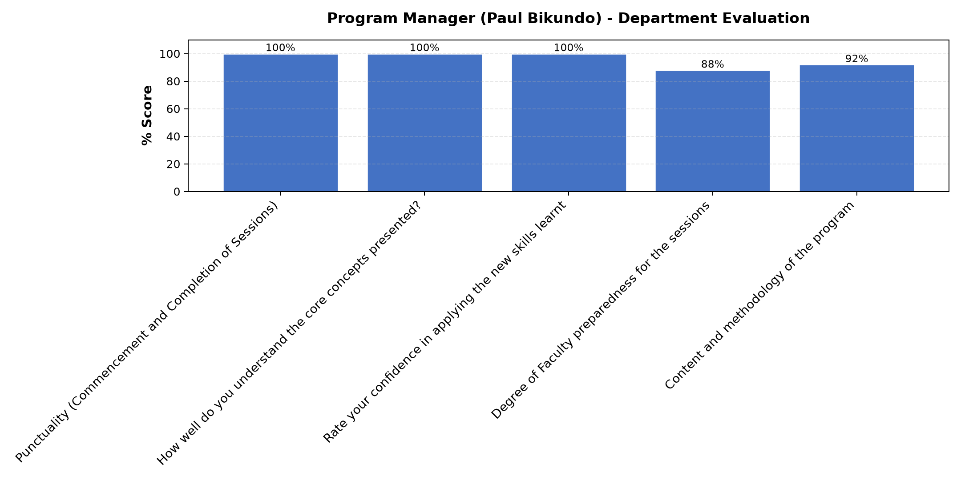

Comments & Feedback
- • We need more knowledge on resource mobilisation.
- • Thank you Mr. Paul for your concern about how we are working in our social enterprises.We will continue improving the betterment of ourselves/learners and parents entrusting their children to our schools so as to build a better future.
- • Continue getting information from the mother superior about how far the social enterprise is
- • He has been instrumental and very helpful
- • It was a very insightful

Review current funding of social

Comments & Feedback
No comments recorded.

What attracted you to the programme??

Comments & Feedback
- • Wanting our sustain our Congregation, apostolates and beneficiaries so that there could be a continuation.
- • All the sessions attracted me because it was a reminder or a signal to me to look back to our social enterprise what we have achieved and challenges faced and improve in our way of running our S.E.
- • The sharing on how far each congregation social enterprise are moving
- • The enrichment that comes in attending the programme in terms of empowerment and help / knowledge to put things in place for the betterment of the Enterprise.
- • Opportunity for assistance

What topic would you recommend being expanded/improved in this programme’s units?

Comments & Feedback
- • Resource mobilisation
- • Customer and competitors
- • About leadership
- • The topics presented were all quite vital to enlighten and help in entrepreneurship.
- • We had some Internet challenge on the day for social impact measure and planning. But the note may help us catch up.

Which areas in this programme did you find most important to your social enterprise?

Comments & Feedback
- • ToC, 5 dimensions of impact, Social impact measures and planning, business plan review
- • Impact measure because it will help our social enterprise to know the difference made in society through our learners' ability to sustain themselves in society.
- • Carnival and the theory of change
- • Discovering more about self , the need to keep record of what we are doing , the input and all the activities related to the entrepreneurship which will help see the impact of what we are doing. I have seen that with good record keeping, it is easier to make references and identify areas of need and were we need to improve
- • All aspect of the program. None is less. I need to go through them again and integrate them in my work.

Which teaching methods applied in the course did you enjoy/learn from the most?

Comments & Feedback
- • Group discussions
- • Discussion teaching method because I was able to learn from Dr Nancy and different congregations are able run their social enterprise.
- • Carnival and the theory of change
- • Presentation/discussion as a Congregation as well contribution from all the Sisters
- • All

